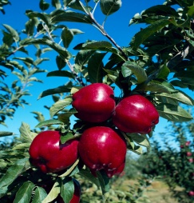
2019 In Orchard Meetings
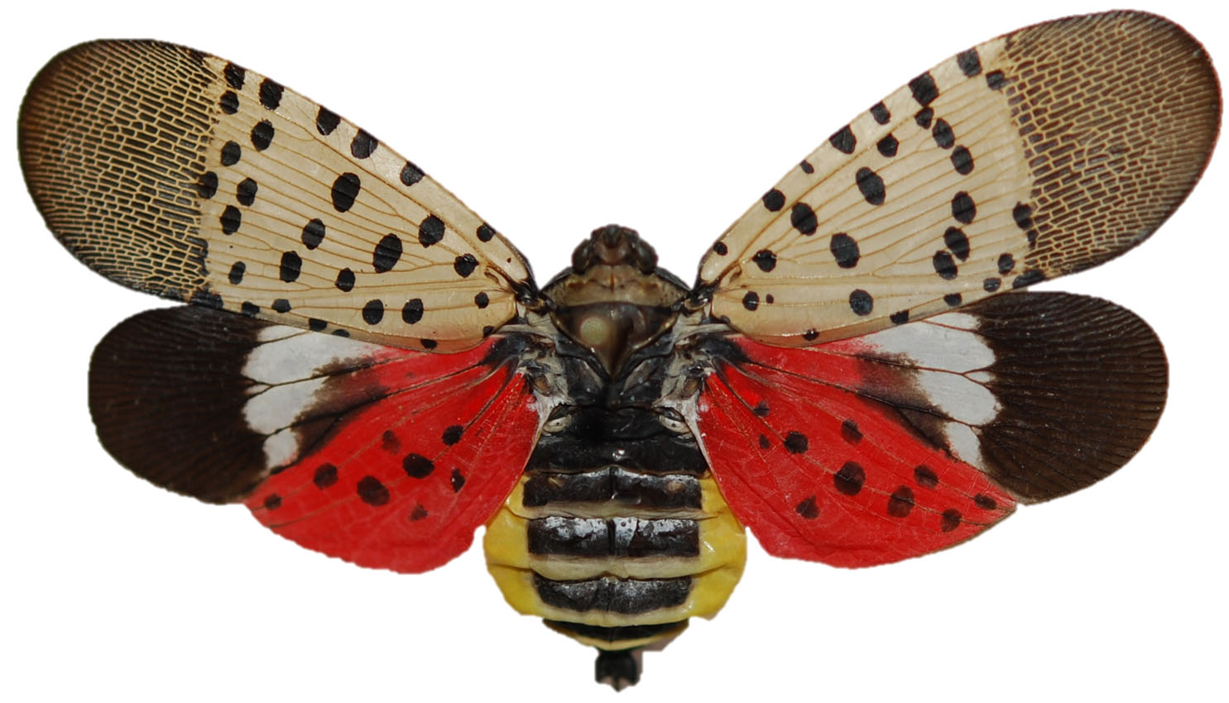
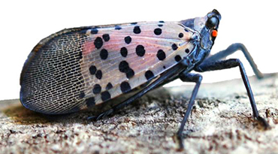
Spotted Lanternfly- Report any sightings to your local VCE 675-3619 or VDACS 804-786-3515

VCE-Spotted Lanternfly in Virginia- https://ext.vt.edu/agriculture/commercial-horticulture/spotted-lanternfly.html

PA-Dept. of Agriculture- http://www.agriculture.pa.gov/Plants_Land_Water/PlantIndustry/Entomology/spotted_lanternfly/program-information/Pages/default.aspx

- April 17th In Orchard Meeting
Williams Orchard, Tommy and Eddie Williams, Flint Hill Rt. 211 east to Ben Venue. At the crossroads, turn north on to Rt. 729 and go approximately 2½ miles. Orchard is on the left. (3 Williams Farm Lane, Flint Hill, VA 22627)
- May 15th In Orchard Meeting
Jenkins Orchard, James Jenkins, Woodville, From Rt. 231, turn right on to Rt. 621, go about 2 miles. The orchard is on the left by the packing shed. (355 Yancey Rd, Woodville, VA 22749)
- June 12th In Orchard Meeting
F.T Valley Orchard, Alan Clark, Sperryville, From Rt. 231, south to orchard on right. (403 F.T. Valley Road Sperryville, VA 22740

- July 24th In Orchard Meeting
Graves’ Mountain Farm, Jimmy Graves, Syria
Rt. 231 to Rt. 670, meet at the picnic shelter on left just past Syria. (3626 Old Blue Ridge Turnpike, Syria, VA 22743)

If you are a person with a disability and desire any assistive devices, services or other accommodations to participate in this activity, please contact Kenner Love, VCE at (540-675-3616/TDD*) during business hours of 8 a.m. and 4:30 p.m.
to discuss accommodations 5 days prior to the event. *TDD number is (800) 828-1120.

